SIMATS ENGINEERING (SAVEETHA SCHOOL OF ENGINEERING)
Department of Computer Science and Engineering
CO2 ASSESSMENT TOOL 1 – Scenario-Based Requirement Analysis

Course Code: | CSA1007 | Course Title: | Software Engineering
CO Assessed: | CO2 | Assessment: | Assessment Tool 1 – Scenario-Based Requirement Analysis
Weightage: | 20% | Total Marks: | 25
CO2 Statement: | Perform detailed requirements analysis, design scalable architectures, and prioritize features with a focus on cross-disciplinary skills
Student Name: | A.Santhosh | Reg. No.: | 192311282
Date: | 30-07-2026 | Duration: | 60 minutes

Code of Conduct
I A.Santhosh, 192311282 (Name / Reg No) certify that this submission is my original work and that I have adhered to the guidelines specified for this assessment. I understand that any violation of academic integrity rules will result in disciplinary action.
Signature of the Student: _________________________
Annexure A – Scenario-Based Requirement Analysis
S.NO-1
Instructions to Students:
Each student will be assigned an individual software project problem statement. Analyze the given scenario and prepare a complete Software Requirement Analysis document by following the steps below.

Question
Based on the assigned problem statement, perform a Scenario-Based Requirement Analysis and prepare a Software Requirement Specification (SRS) document. Your analysis should include the following:
- Study and Analyze the Scenario
  - Carefully understand the given problem statement.
  - Identify the business domain, stakeholders, existing challenges, and system objectives.
- Identify Functional and Non-Functional Requirements
  - List all functional requirements required by the proposed system.
  - Identify suitable non-functional requirements such as performance, security, reliability, usability, scalability, maintainability, and availability.
- Identify Actors and Use Cases
  - Identify all primary and secondary actors interacting with the system.
  - List the major use cases associated with each actor.
  - Draw a Use Case Diagram representing the interactions between actors and the system.
- Prepare the Software Requirement Specification (SRS)
Develop an SRS document containing:
  - Introduction
  - Problem Description
  - Scope of the System
  - Functional Requirements
  - Non-Functional Requirements
  - Use Case Descriptions
  - Data Requirements
  - External Interface Requirements
  - System Features
- Identify Assumptions and Constraints
  - List the assumptions considered while developing the system.
  - Identify technical, operational, economic, legal, and time-related constraints affecting the project.
- Validate Requirement Completeness and Consistency
  - Verify whether all stakeholder requirements have been addressed.
  - Check for ambiguity, redundancy, inconsistency, and missing requirements.
Suggest improvements to enhance the quality and completeness of the requirement specification.

Smart Traffic Congestion Management Platform
1. Introduction
1.1 Purpose
This Software Requirement Specification (SRS) document describes the functional and non-functional requirements of the proposed Smart Traffic Congestion Management Platform. The purpose of the system is to reduce urban traffic congestion by collecting real-time data from road sensors, CCTV cameras, GPS-enabled vehicles and weather services, analyzing this data to detect and predict congestion, dynamically optimizing signal timings, prioritizing emergency vehicles at intersections, and keeping commuters and traffic authorities informed through mobile applications and analytical dashboards.
1.2 Business Domain and Overview
The system belongs to the Intelligent Transportation Systems (ITS) / Smart City domain. Rapid urbanization has increased the number of vehicles on city roads, and traditional traffic control systems that rely on static signal timings and manual monitoring are no longer able to handle peak-hour traffic or unexpected incidents efficiently. Emergency vehicles are frequently delayed at congested intersections, and municipal authorities lack accurate, real-time analytics for infrastructure planning. A distributed, data-driven platform is therefore required to continuously sense road conditions, make intelligent signal-control decisions, and provide actionable insight to both citizens and administrators.
1.3 Stakeholders
Commuters who use city roads and need accurate, real-time travel information.
Traffic control operators who monitor junctions and manage signal operations.
Municipal traffic authorities responsible for planning and policy decisions.
Emergency dispatch services (ambulance, fire, police) requiring priority passage.
System administrators who maintain sensors, cameras and platform infrastructure.
Third-party data providers such as weather services and GPS/map providers.
1.4 Existing Challenges
Static, fixed-time traffic signals that do not adapt to real traffic density.
Manual, reactive monitoring that cannot scale across an entire city.
Delayed emergency response caused by congestion at intersections.
Absence of consolidated, real-time analytics for infrastructure planning.
Fragmented data sources (sensors, cameras, GPS, weather) with no unified platform.
1.5 System Objectives
Monitor live traffic flow across intersections and road segments in real time.
Predict congestion hotspots before they occur using historical and live data.
Dynamically optimize traffic signal timing based on current conditions.
Detect and prioritize emergency vehicles to reduce response time.
Generate traffic analytics and historical reports for strategic planning.
Notify commuters of congestion, incidents and alternate routes through a mobile app.
2. Problem Description
City authorities need a distributed Smart Traffic Congestion Management Platform that collects live traffic data from sensors, CCTV cameras, GPS-enabled vehicles and weather services; analyzes traffic density in real time; optimizes signal timings; prioritizes emergency vehicles; predicts congestion hotspots; and notifies commuters through mobile applications. The platform must also provide traffic authorities with dashboards, analytics and historical reports to support infrastructure and policy decisions. The expected outcomes are reduced travel time, lower fuel consumption, improved emergency response, better road utilization and more accurate traffic forecasting.
3. Scope of the System
The system will cover data acquisition from field devices, real-time traffic analytics, adaptive signal control, emergency vehicle prioritization, commuter notification through a mobile application, and reporting dashboards for authorities. The scope includes all city intersections equipped with compatible sensors and signal controllers. The system will interoperate with existing traffic signal hardware through standard control interfaces and will not replace physical signal equipment. Deep-integration with vehicle manufacturers or nationwide inter-city traffic networks is outside the scope of this phase.
4. Functional Requirements
- FR-1: Data Acquisition – The system shall continuously collect data from road sensors, CCTV cameras, GPS-enabled vehicles and weather services.
- FR-2: Traffic Density Analysis – The system shall analyze incoming data to compute real-time traffic density for each monitored road segment and intersection.
- FR-3: Congestion Prediction – The system shall use historical and live data to predict congestion hotspots and estimated time-to-congestion.
- FR-4: Adaptive Signal Optimization – The system shall dynamically compute and apply optimal signal timings based on current and predicted traffic conditions.
- FR-5: Emergency Vehicle Prioritization – The system shall detect approaching emergency vehicles and adjust signal phases to grant priority passage.
- FR-6: Commuter Notification – The system shall send real-time alerts (congestion, incidents, alternate routes) to commuters through a mobile application.
- FR-7: Authority Dashboard – The system shall provide traffic authorities with a live dashboard showing traffic density, incidents and signal status.
- FR-8: Analytics and Reporting – The system shall generate historical traffic reports and analytics for infrastructure planning.
- FR-9: Incident Reporting – The system shall allow commuters and operators to report accidents or road obstructions.
- FR-10: User and Access Management – The system shall authenticate operators and authority users and control access based on role.
- FR-11: Sensor and Camera Configuration – The system shall allow administrators to register, configure and monitor the health of sensors and cameras.
5. Non-Functional Requirements
Performance: The system shall process live sensor and camera feeds and update signal recommendations within 2–3 seconds under normal load.
Scalability: The system shall be able to scale horizontally to support additional intersections, sensors and cameras as the city network grows.
Reliability: The system shall maintain at least 99.5% uptime for core traffic-monitoring and signal-control services.
Availability: Critical services (signal optimization, emergency prioritization) shall remain available even if a subset of sensors goes offline, degrading gracefully.
Security: The system shall encrypt data in transit and at rest and restrict signal-control actions to authenticated, authorized operators.
Usability: The commuter mobile application and authority dashboard shall be intuitive and usable by non-technical users with minimal training.
Maintainability: The system shall be built using modular, loosely coupled services so that components can be updated or replaced independently.
Interoperability: The system shall integrate with existing traffic-signal controllers and third-party GPS/weather data providers through standard APIs.
Data Retention: The system shall retain historical traffic data for a configurable period to support trend analysis and reporting.

6. Actors and Use Cases
6.1 Primary and Secondary Actors
Actor | Type | Role in the System
Commuter | Primary | Receives congestion alerts and route notifications; can report incidents.
Traffic Control Operator | Primary | Monitors live traffic, reviews signal recommendations and configures field devices.
Municipal Traffic Authority | Primary | Views analytics dashboards and historical reports for planning decisions.
Emergency Dispatch Service | Primary | Triggers emergency-vehicle prioritization requests at intersections.
Sensors / CCTV / GPS / Weather Feed | Secondary (External System) | Supplies continuous raw traffic and environmental data to the platform.

6.2 Major Use Cases per Actor
Commuter: Login/Authenticate, Report Incident, Receive Congestion Notifications.
Traffic Control Operator: Monitor Live Traffic Data, Optimize Signal Timing, Configure Sensors & Cameras, Report Incident.
Municipal Traffic Authority: View Analytics & Dashboards, Generate Historical Reports.
Emergency Dispatch Service: Prioritize Emergency Vehicle Passage.
Sensors / CCTV / GPS / Weather Feed: Feed live data into Monitor Live Traffic Data and Predict Congestion Hotspots use cases.
6.3 Use Case Diagram
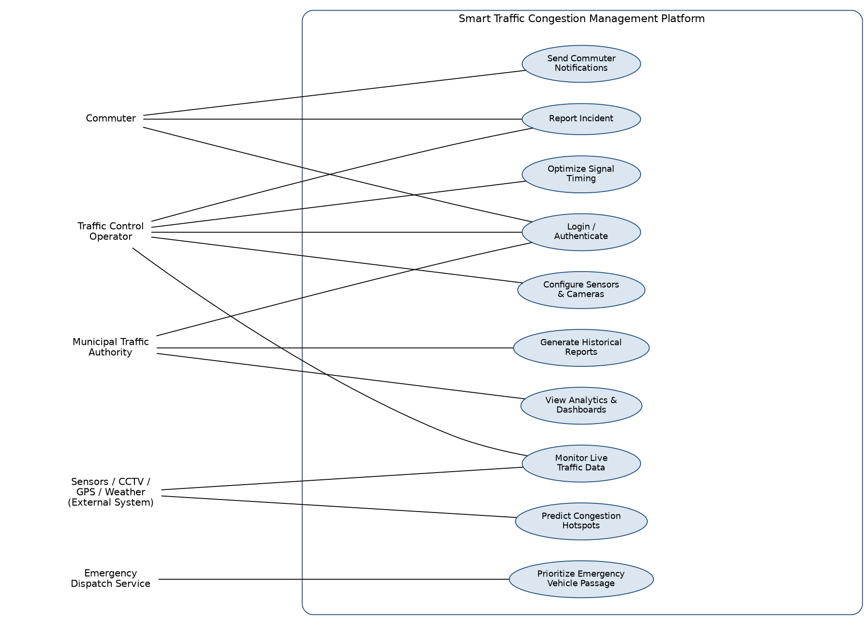
Figure 1: Use Case Diagram – Smart Traffic Congestion Management Platform
6.4 Use Case Descriptions
ID | Use Case | Actor(s) | Precondition | Postcondition
UC-1 | Monitor Live Traffic Data | Traffic Control Operator, Sensors/CCTV | Devices are online and transmitting data. | Current traffic density is displayed on the dashboard.
UC-2 | Predict Congestion Hotspots | System (automated), Sensors/CCTV | Sufficient historical data exists. | Predicted hotspot list is generated and stored.
UC-3 | Optimize Signal Timing | Traffic Control Operator | Traffic density data is available. | Updated signal plan is applied at the intersection.
UC-4 | Prioritize Emergency Vehicle | Emergency Dispatch Service | Emergency vehicle is registered/detected. | Green corridor is created along the vehicle route.
UC-5 | Send Commuter Notification | Commuter | Commuter app is installed and location enabled. | Commuter receives a real-time alert.
UC-6 | View Analytics & Dashboards | Municipal Traffic Authority | User is authenticated. | Dashboard displays requested analytics.
UC-7 | Report Incident | Commuter, Traffic Control Operator | User is logged in. | Incident is logged and flagged for review.

7. Data Requirements
Real-time traffic data: vehicle counts, speed, and lane occupancy per road segment.
CCTV video/image streams and derived congestion indicators.
GPS probe data from connected vehicles (location, speed, timestamp).
Weather data (rainfall, visibility, temperature) affecting road conditions.
Signal timing plans and historical signal-change logs.
Incident reports submitted by commuters and operators.
Historical traffic and analytics data retained for trend analysis and reporting.
User and role data for operators and authority accounts.
8. External Interface Requirements
8.1 User Interfaces
Commuter mobile application (Android/iOS) for alerts, routes and incident reporting.
Web-based dashboard for traffic control operators and municipal authorities.
8.2 Hardware Interfaces
Interfaces to roadside sensors, CCTV cameras and traffic signal controllers.
Interfaces to edge/gateway devices that aggregate field-device data.
8.3 Software Interfaces
APIs for GPS/map providers and weather data services.
Integration APIs for emergency dispatch systems.
Database and analytics platform interfaces for storage and reporting.
8.4 Communication Interfaces
Secure REST/HTTPS APIs and message-queue based data ingestion for real-time feeds.
Push-notification services for commuter alerts.
9. System Features
Real-time traffic monitoring dashboard with map-based visualization.
Predictive congestion analytics using historical and live traffic patterns.
Adaptive signal control engine that recalculates timings per intersection.
Emergency green-corridor creation for priority vehicle routing.
Commuter mobile alerts with alternate-route suggestions.
Historical reporting and analytics module for infrastructure planning.
Incident reporting and tracking workflow.
Role-based access control for operators and authority users.
10. Assumptions and Constraints
10.1 Assumptions
Sensors, cameras and GPS-enabled vehicles provide continuous, reasonably accurate data.
Intersections targeted for adaptive control have compatible signal controllers.
Commuters who wish to receive alerts have the mobile application installed.
Weather and map data providers offer stable, documented APIs.
10.2 Constraints
Technical: Legacy signal controllers at some intersections may have limited connectivity.
Operational: Field-device maintenance and connectivity depend on municipal infrastructure teams.
Economic: Sensor and camera coverage is limited by the available capital and maintenance budget.
Legal: Data collection (e.g., CCTV, GPS) must comply with local privacy and data-protection regulations.
Time-related: Citywide rollout must be phased due to installation and integration timelines.
11. Requirement Validation – Completeness and Consistency
The requirements listed above were cross-checked against the stakeholders and objectives identified in Section 1 to confirm that every stakeholder need is addressed by at least one functional or non-functional requirement. Commuters are served by notification and incident-reporting requirements; operators by monitoring, configuration and signal-optimization requirements; authorities by analytics and reporting requirements; and emergency services by the prioritization requirement.
11.1 Consistency and Ambiguity Check
No conflicting requirements were identified; each functional requirement maps to a distinct system capability.
Performance and reliability non-functional requirements were reviewed to ensure they do not contradict the scalability requirement.
Terms such as "real time" were clarified with measurable targets (e.g., 2–3 second update interval) to remove ambiguity.
11.2 Suggested Improvements
Add explicit data-retention and privacy-compliance requirements for CCTV and GPS data.
Define measurable service-level targets for each non-functional requirement in a future revision.
Introduce a requirements traceability matrix to formally map each stakeholder need to specific requirements and test cases.
Appendix: Assessment Rubrics
Rubrics for Calculation
Criteria | Excellent (4 Marks) | Good (3 Marks) | Satisfactory (2 Marks) | Needs Improvement (1 Mark)
Scenario Understanding and Problem Analysis | Demonstrates thorough understanding of the scenario, stakeholders, objectives, and business context with clear analysis. | Demonstrates good understanding with minor omissions. | Basic understanding with limited analysis. | Poor understanding; major aspects missing or incorrect.
Functional and Non-Functional Requirement Identification | Clearly identifies comprehensive, accurate, and well-classified functional and non-functional requirements. | Identifies most requirements with minor classification errors. | Identifies only basic requirements; several omissions. | Requirements are incomplete, inaccurate, or poorly classified.
Actor Identification and Use Case Modeling | Correctly identifies all relevant actors and use cases; use case diagram is complete, accurate, and follows UML standards. | Most actors and use cases identified; diagram has minor errors. | Limited actors/use cases identified; diagram partially correct. | Actors/use cases missing or incorrect; diagram absent or inaccurate.
Software Requirement Specification (SRS) Documentation | SRS is well-structured, complete, professionally organized, and includes all required sections. | SRS is organized with minor missing sections or formatting issues. | SRS includes only essential sections with limited detail. | SRS is incomplete, poorly organized, or lacks essential components.
Assumptions, Constraints, and Requirement Validation | Clearly identifies realistic assumptions and constraints; validates requirements for completeness, consistency, and ambiguity with appropriate justification. | Identifies most assumptions and constraints; validation is adequate. | Limited assumptions/constraints; validation is superficial. | Assumptions, constraints, and validation are missing or incorrect.

Criteria | Mark
Scenario Understanding and Problem Analysis | /5
Functional and Non-Functional Requirement Identification | /5
Actor Identification and Use Case Modeling | /5
Software Requirement Specification (SRS) Documentation | /5
Assumptions, Constraints, and Requirement Validation | /5
TOTAL | /5

